Name : s.PadmaPriya

Reg no:192111009

1 . print enter the welcome in java?

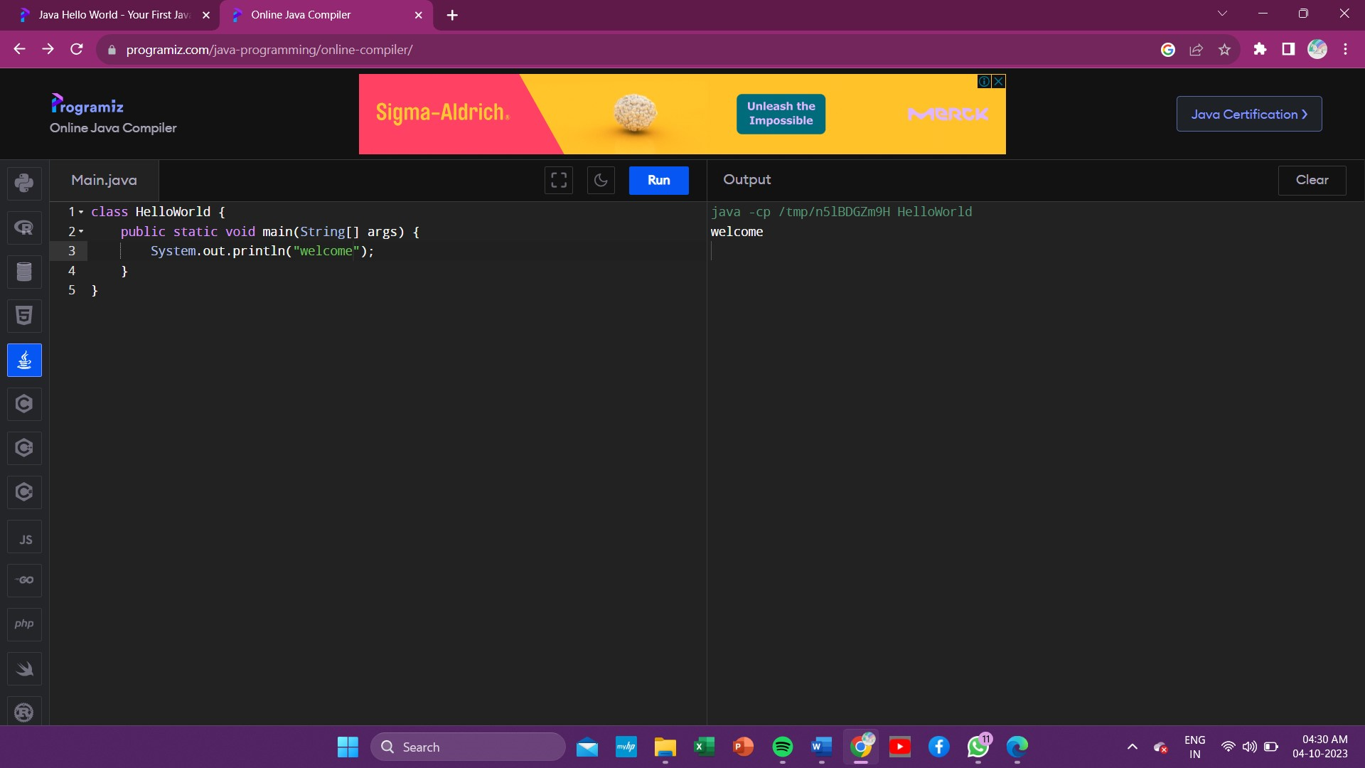

2.convert the Celsius into Fahrenheit in java using scanner ?

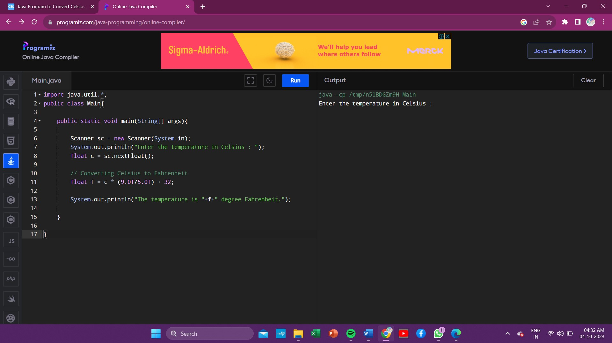

3 . print the sum of two numbers in java using scanner ?

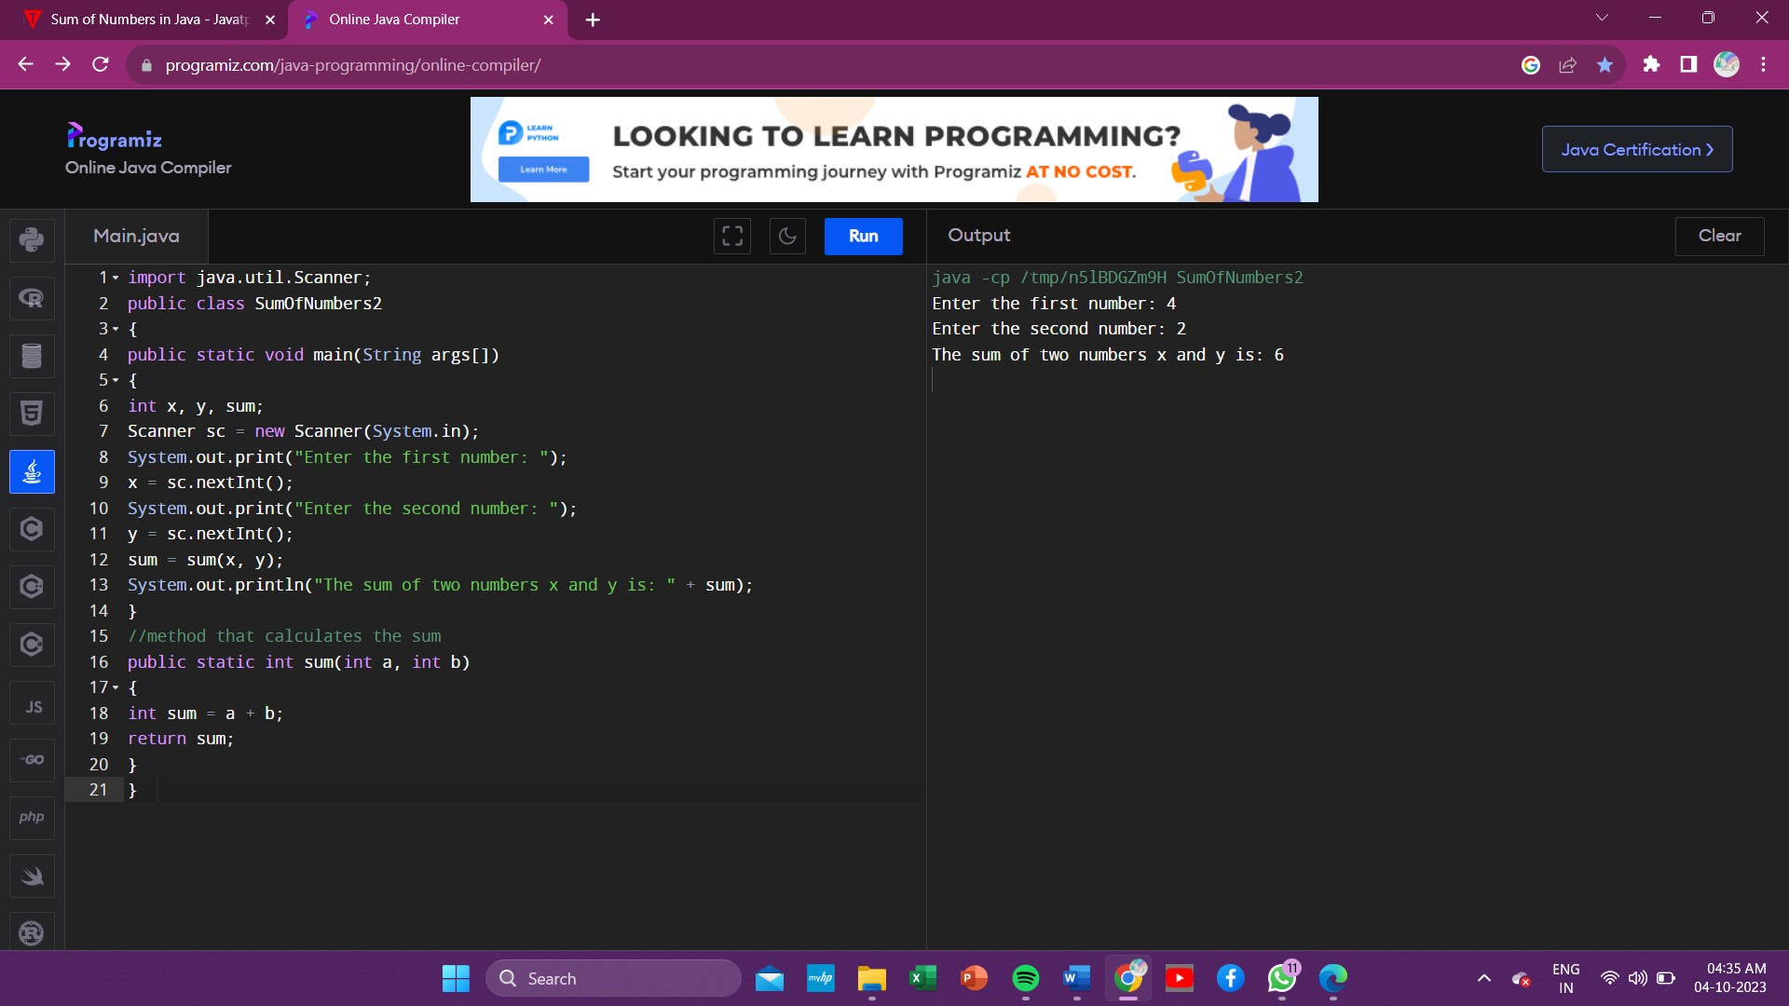

4 . print odd or even in java using scanner ?

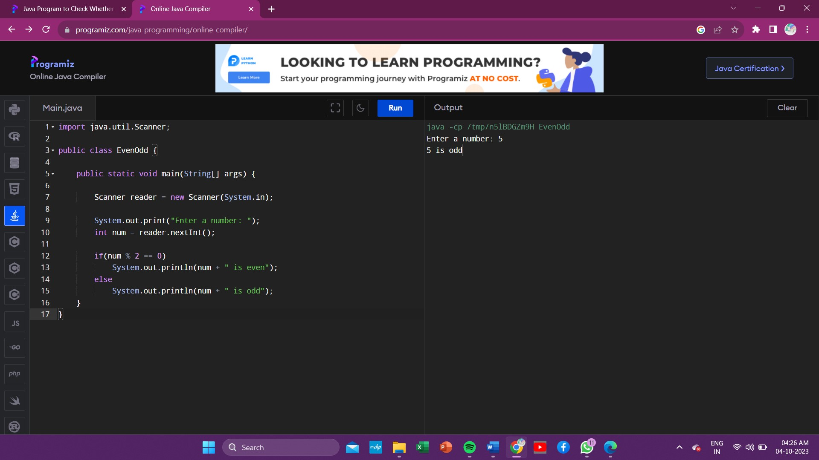

5 . print wheather the given year is leap year or not using scanner ?

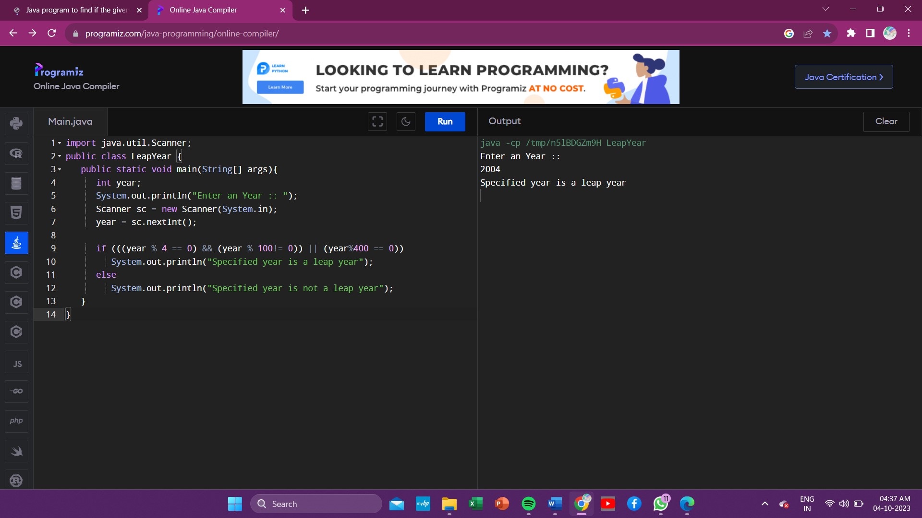

6 . check wheather the given number is a positive or negative in java using scanner?

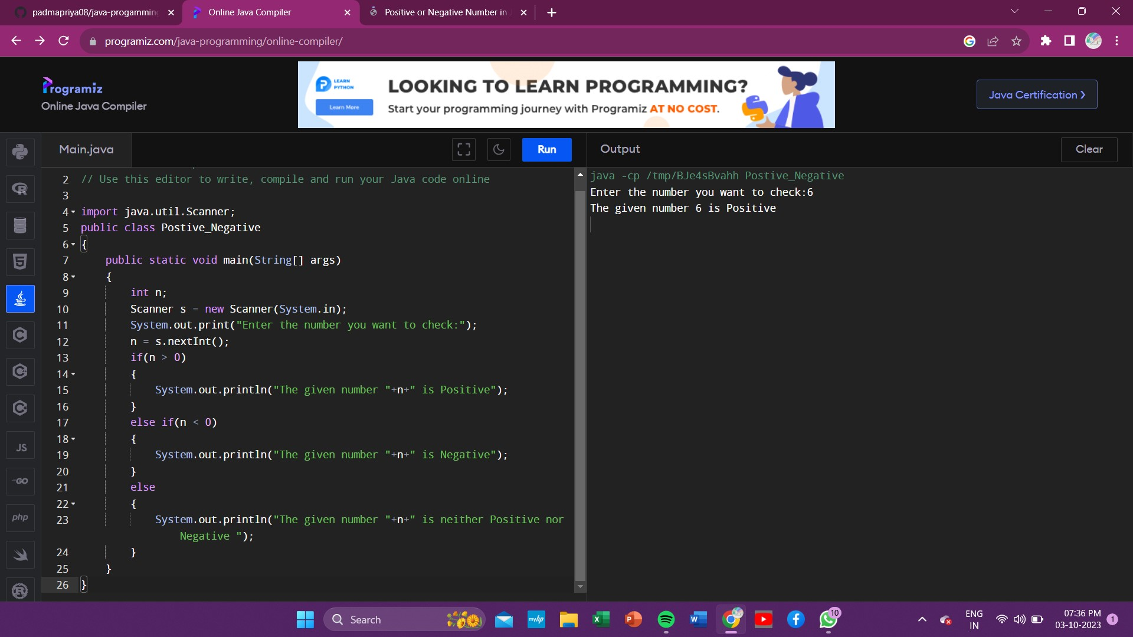

7 . check wheather the person the eligible for voting or not in java using scanner ?

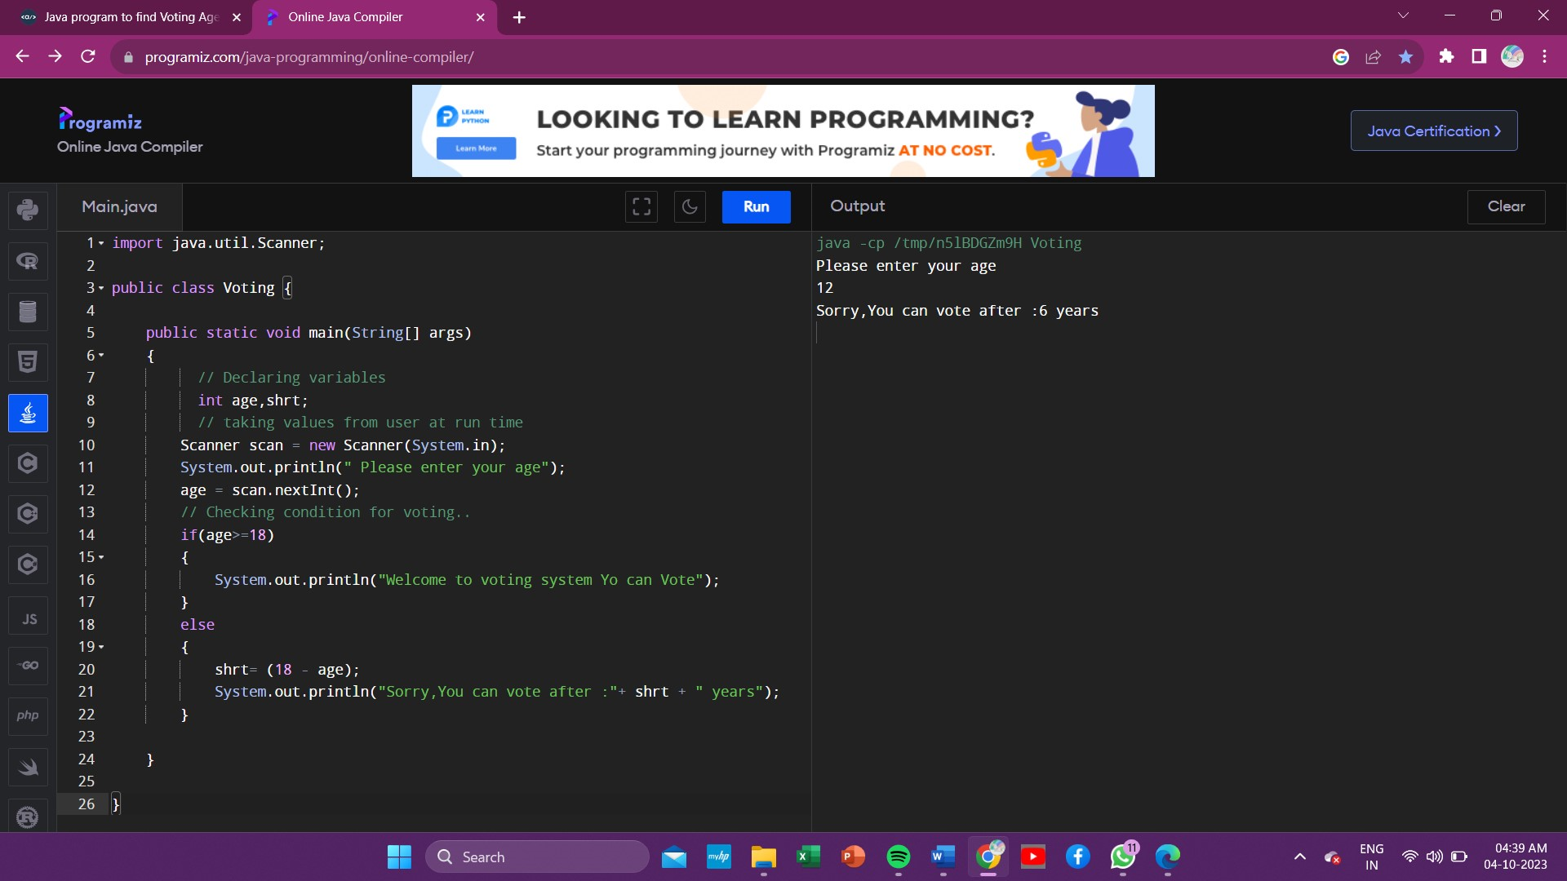

8 . print the sum of series in java using scanner ?

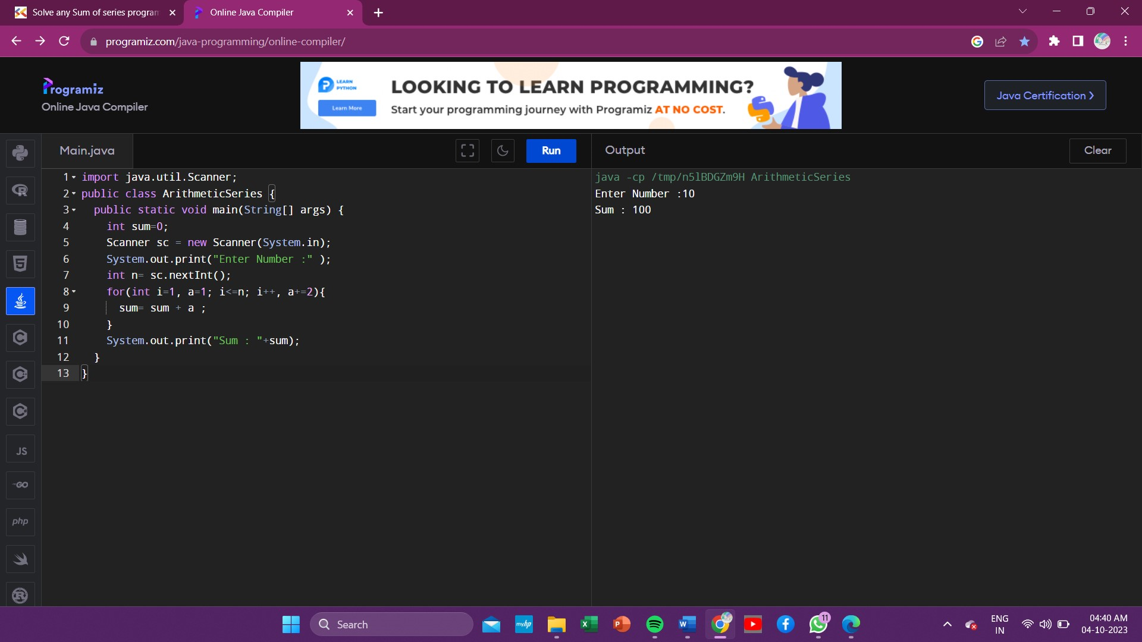

9 . print the factorial of a number in java using scanner ?

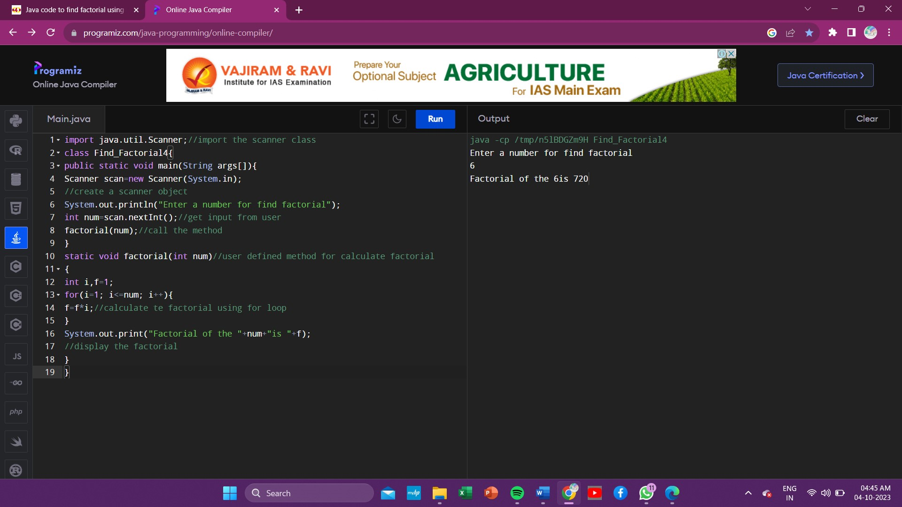

10 .check wheather the given number is prime or not in java using scanner ?

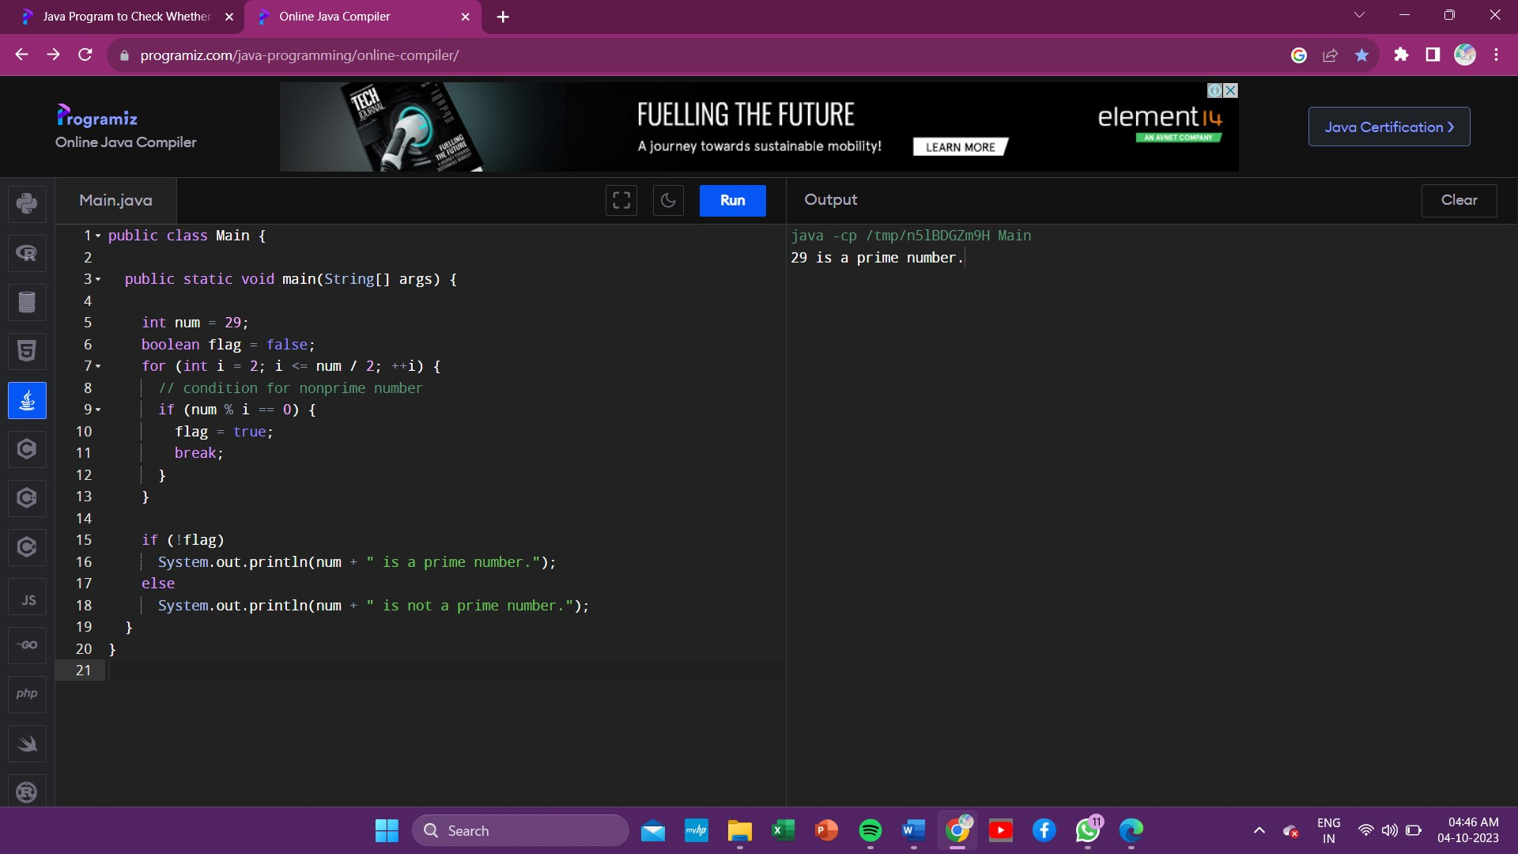

11 . check wheather the given number is armstrong or not in java using scanner ?

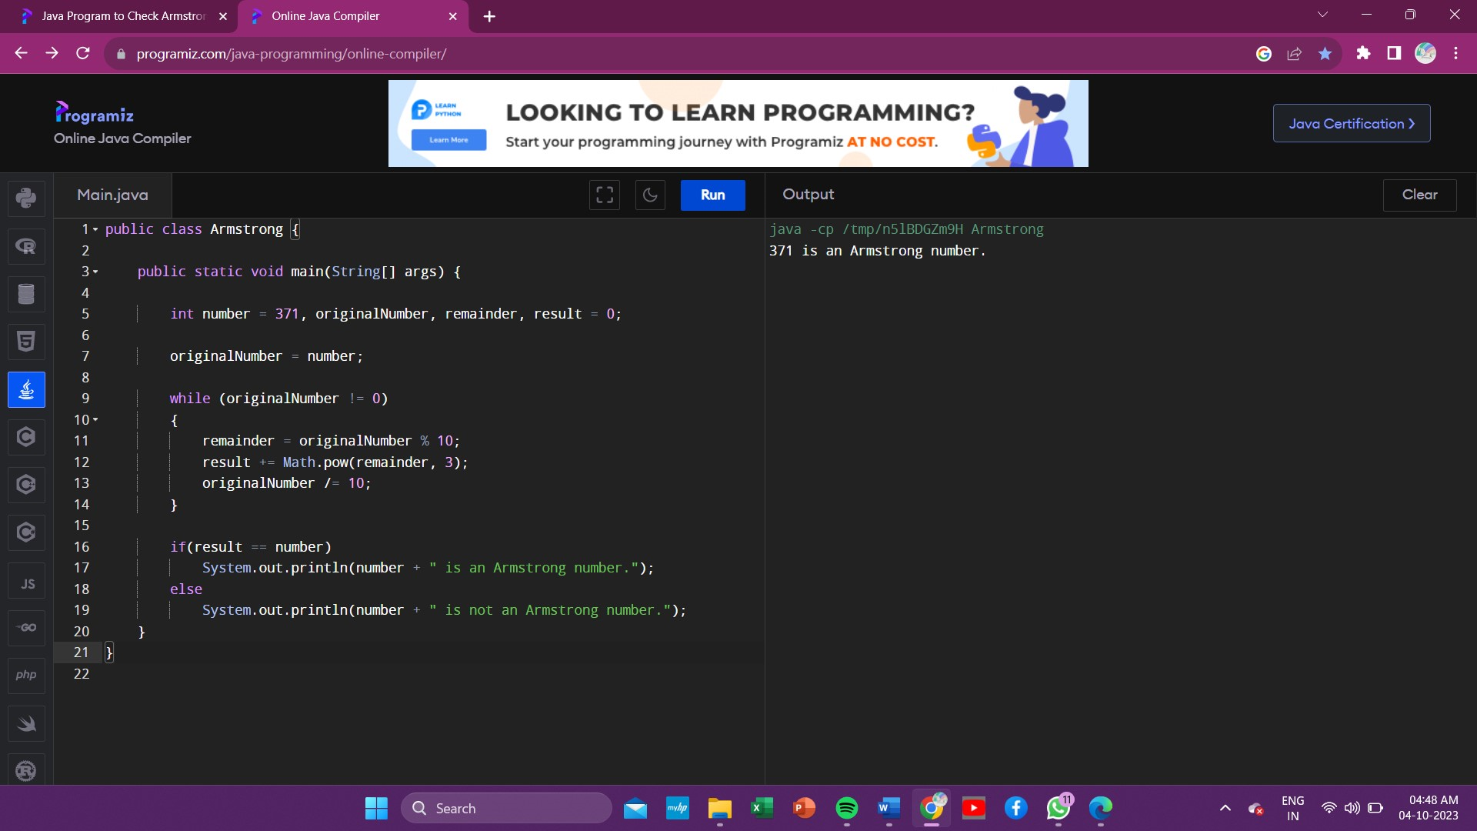

12 . check wheather palindrome or not in java using scanner ?

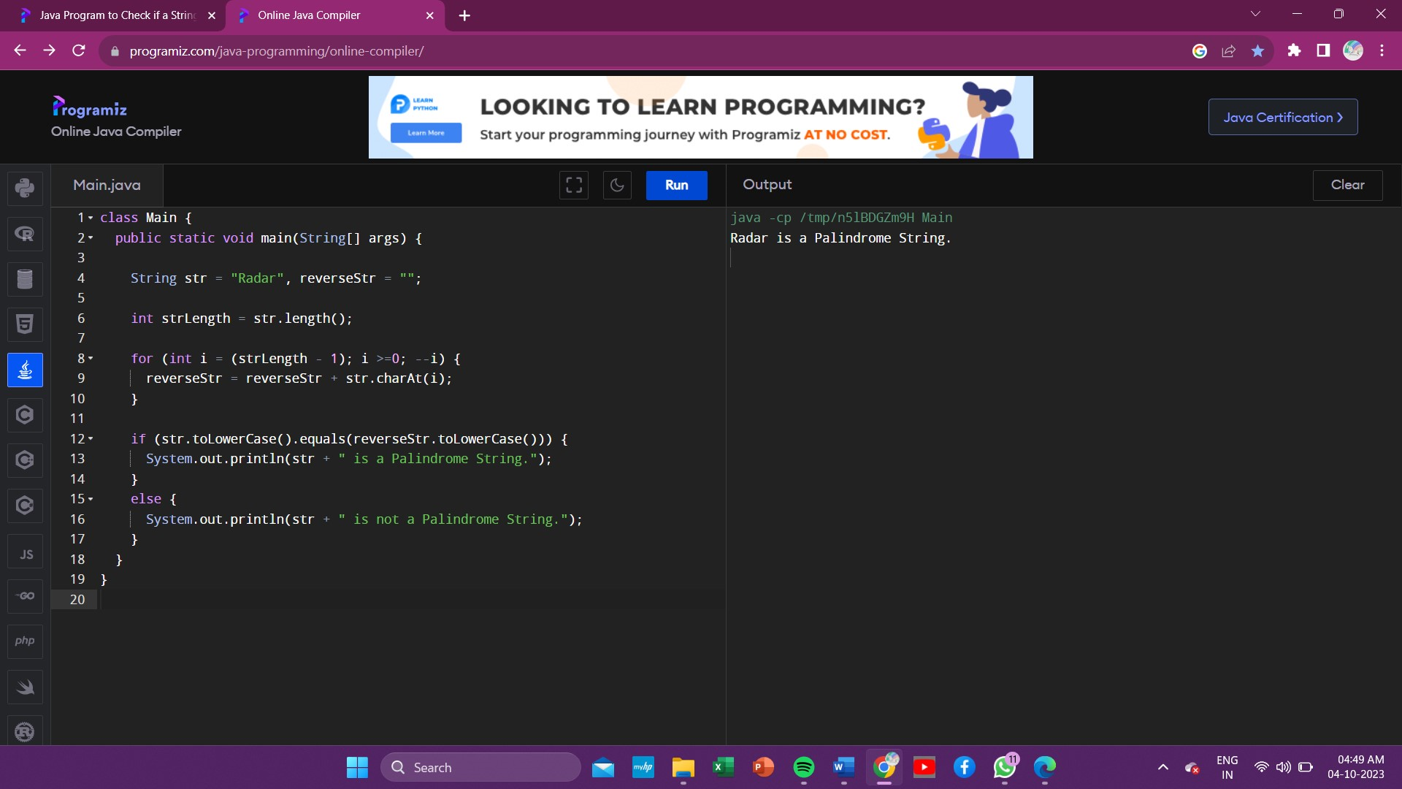

13 . ascii number?

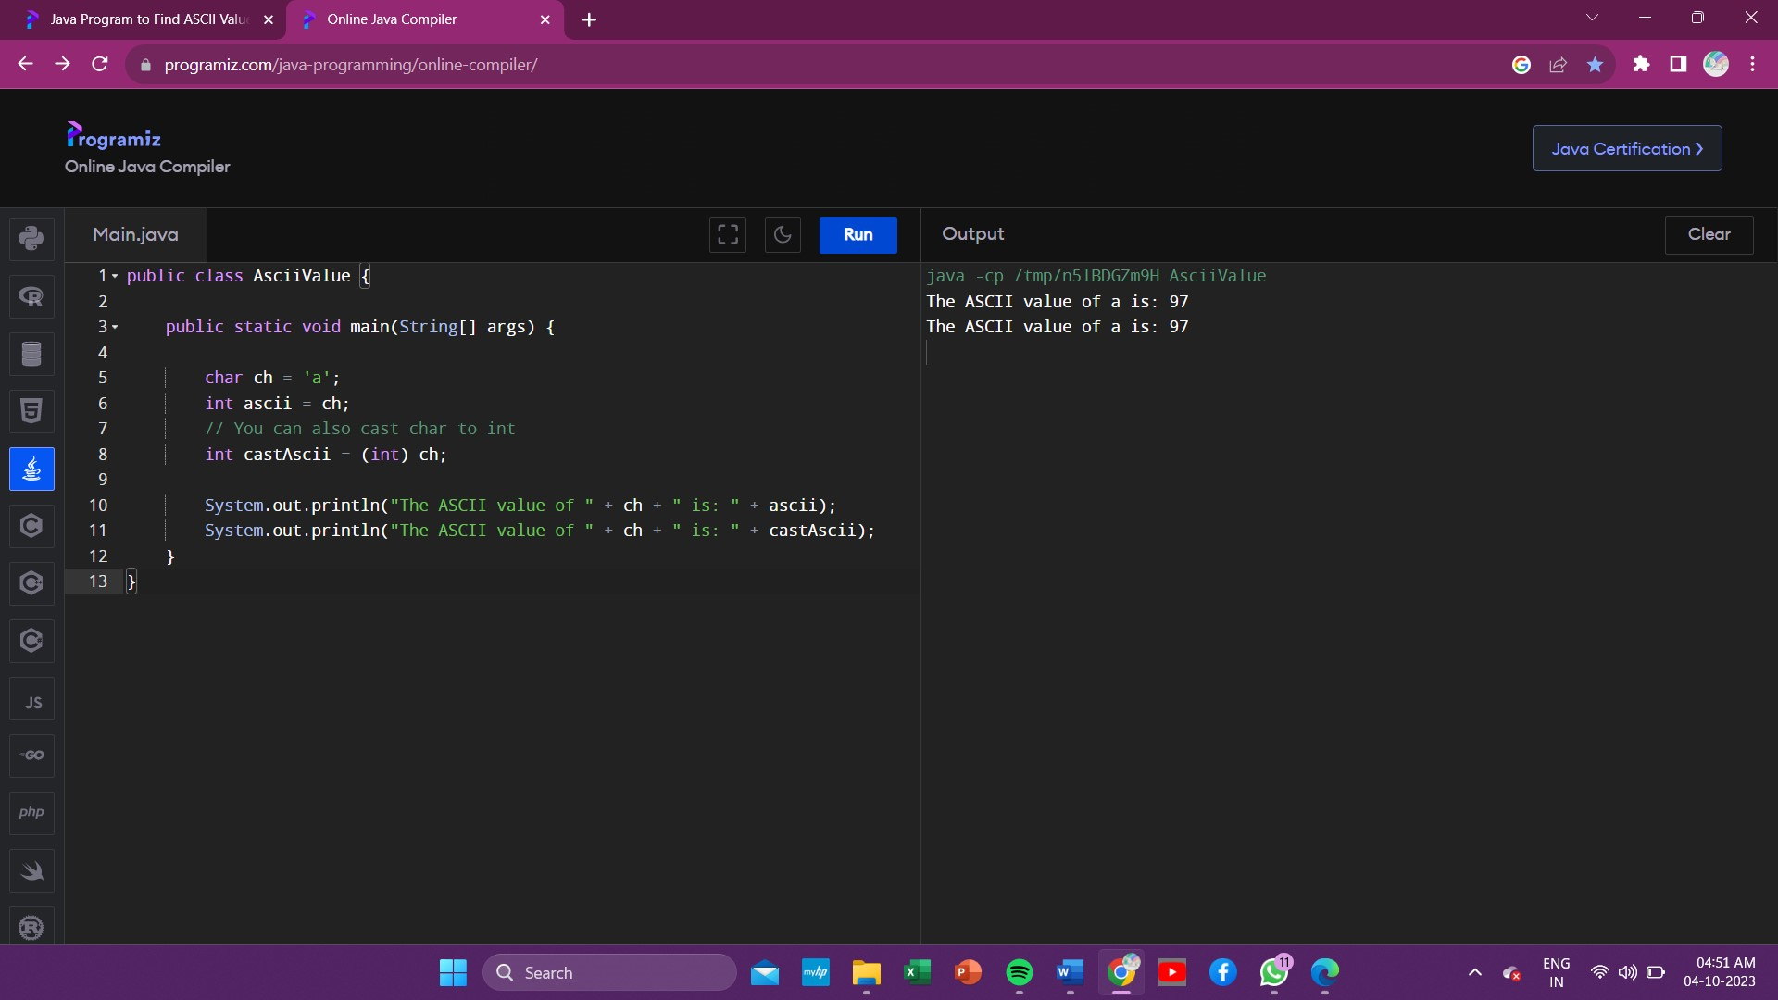

14.program to reverse a number?

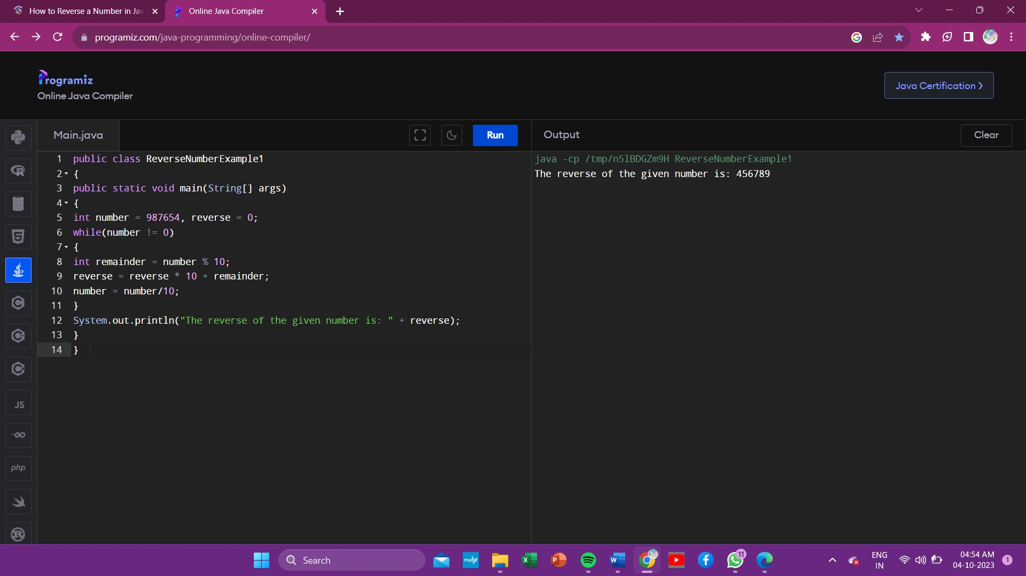

15 . while loop in summation ?

